**SMART BOT SYSTEM WEBSITE**

**PROJECT REPORT**

***Submitted in partial fulfillment of the requirements for the award of the degree***

***Of***

**BACHELOR OF TECHNOLOGY**

**BTTS-601**

**IN**

**COMPUTER SCIENCE**

**Under the Guidance of Submitted by**

**DR. SITA RANI Sanjeev Maurya, 1806624**

**Professor Sloka Sakshi, 1806638**

**CSE/IT DEPARTMENT Priyanka Sharma, 1906374**

**Sharanjeet Kaur, 1806631**





ਆਈ. ਕੇ. ਗੁਜਰਾਲ ਪੰਜਾਬ ਟੈਕਨੀਕਲ ਯੂਨੀਵਰਸਿਟੀ, ਜਲੰਧਰ

I.K. GUJRAL PUNJAB TECHNICAL UNIVERSITY, JALANDHAR

# CANDIDATE’S DECLARATION AND CERTIFICATE

We hereby certify that the work, which is being presented in this report entitled, **SMART BOT SYSTEM WEBSITE**  in partial fulfillment of the requirements for the degree of **B.Tech CSE, BTTS-601** submitted in the **CSE & IT** **Department** Gulzar Group of Institutions, Ludhiana, Punjab; by **Sanjeev Maurya(1806638), Sloka Sakshi(1806638), Priyanka Sharma(1906374), Sharanjeet Kaur(1806631)** is the authentic record of our own work carried out under the supervision of **DR. Sita Rani, Professor, CSE & IT Department** Gulzar Group of Institutions, Ludhiana, Punjab.

We further declare that the matter embodied in this report has not been submitted by us for the award of any other degree.

**Candidate(s) Signature**

This is to certify that the above statement made by the candidate is correct to the best of my knowledge and belief.

**Signature of HOD Signature of Supervisor**

**Er, Khushwant Kaur DR. Sita Rani**

Date:

**ACKNOWLEDGMENT**

It is our pleasure to acknowledge the contributions of all who have helped us and supported us during this Project report.

First, we thank God for helping us in one way or another and providing strength and endurance to us. We wish to express my sincere gratitude and indebtedness to our supervisor Dr. Sita Rani, Professor, CSE & IT Department Gulzar Group of Institutions, Ludhiana, and Punjab; for his intuitive and meticulous guidance and perpetual inspiration in completion of this report. In spite of his busy schedule, he rendered help whenever needed, giving useful suggestions and holding informal discussions. His invaluable guidance and support throughout this work cannot be written down in few words. We also thank him for providing facilities for my work in the department.

We are also humbly obliged by the support of our group members and friends for their love and caring attitude. The sentimental support they rendered to us is invaluable and everlasting. They have helped us through thick and thin and enabled us to complete the work with joy and vigor. We thank the group members for entrusting in each other and following directions, without them this report would never have been possible.

We are also thankful to our parents, elders and all family members for their blessing, motivation and inspiration throughout our work and bearing with us even during stress and bad temper. They have always provided us a high moral support and contributed in all possible ways in completion of this Capstone report.

**ABSTRACT**

The purpose of SMART BOT System and website is to automate the existing manual system by the help of computerized equipment and full-fledged computer software. Fulfilling their requirements, so that their valuable data information can be stored for a longer period with easy accessing and manipulation of the same. The required software and hardware are easily available and easy to work.

Conversational agents change the way we think and live, as they have the ability of being present and ready to provide help anytime and anywhere. From mobile phones or PCs to smart homes, virtual assistants may ease our lives, by doing tasks while conducting conversations. The effects bots can have on education change the humanity forever, implementing new educational principles designed as complementary to traditional methods and to teachers.

They may have a major role in delivering pedagogical content and assessing, covering a wide variety of lessons and subjects by using multimedia content and speeches. New eye candy ways of evaluating students and perpetual learning may be conceived, while getting real time feedback from targeted learners.

They convincingly simulate how a human would behave as a conversational partner and enhance the attraction of technology, gaining the trust of the students. To sum up, Smart Bot may be cheap and easy to use educational tools, meant to be closer to nowadays students in a more pleasant way, adequate to modern styles of learning. This technology, could have a large potential in schools, universities and other training scenarios, reaching a wide variety of targets. The future belongs to robots, and they are already here. Robots surround us, even though they may not have the shape the users imagine. This paper discusses the development and capabilities of conversational agents and the added value they can bring to the educational process: the concept of Smart Bot is provided, the most important frameworks are underlined, a set of successful educational examples of Smart Bot, the benefits and challenges of using Smart Bot

in education are also reviewed. In the end, a model of using an education Smart Bot to increase quality of life is proposed.

# TABLE OF CONTENTS

**Chapter No. Title Page No.**

**CANDIDATE’S DECLARATION AND CERTIFICATE…....................... 2**

**ACKNOWLEDGMENT……………………………………………………... 3**

**ABSTRACT…………………………………………………………………... 4**

**TABLE OF CONTENTS………………………………………….…………. 5**

**LIST OF TABLES…………………………………………………………… 8**

**LIST OF FIGURES…………………………………………………………... 9**

1. **INTRODUCTION…………………………………………............................. 10**
   1. Introduction of the Project Smart Bot system website…………… 10
2. **REVIEW OF LITERATURE ……………………………………………. 11**
   1. Review. ……………………………………………………………… 11
3. **RATIONALE AND SCOPE OF THE STUDY (INCLUDING PROBLEM STATEMENT) ……………………………………………………………… 12** 
   1. Scope of the Study…………………………………………….……. 12
   2. Problem Statement…………………………………………….……. 13
   3. Proposed system……………………………………………….……. 13
   4. Reports of the project. ……………………………………….……… 16
   5. Features of the project. …………………………………….……… 17
   6. Input data and Validations. ………………………………….…….. 18
4. **OBJECTIVES OF THE STUDY …………………………………………… 19**
   1. Objective. …………………………………………………………… 19
   2. Software requirement specification. ………………………………… 20
   3. Identification of need. …………………………………………….… 20
   4. Feasibility study. ……………………………………………….…… 22
5. **RESEARCH METHODOLOGY (SYSTEM FLOWCHART AND DIAGRAM) (IF APPLICABLE) …………………………………………………………………. 23**
   1. System design of the project. ………………………………………… 23
   2. User interface design. ………………………………………………… 24
   3. Preliminary product design. ………………………………………… . 24
   4. Project category. ……………………………………………………… 26
   5. Implementation methodology. ………………………………………... 27
   6. System analysis. ………………………………………………….…… 28
   7. Existing system of the project. ………………………………………… 29
   8. Proposed system. ………………………………………………………. 29
6. **COMPLETE WORK PLAN WITH TIMELINES ……………………………. 30**
   1. Project planning. ……………………………………………………….. 31
   2. Cost estimation of the project. ………………………………………….. 32
   3. Hardware and software requirement specification. ………………...…… 33
   4. Project profile. ………………………………………………………… 34
   5. Purposed System …………………………………………………………. 37
   6. PERT chart. …………………………………………………………..... 42
   7. GANTT chart. …………………………………………………………. 43
   8. Use case model of the project. ………………………………………… 44
   9. About ER diagram. ………………………………………..…………... 45
   10. Security testing. ……………………………………………………..… 47
   11. Implementation and software specification testing. …………………... 47
   12. Data dictionary. ……………………………………………………….. 51
7. **RESULTS & DISCUSSION ……………………………………………………** 
   1. User interfaces. ………………………………………………………… 48
   2. Future scope of the project. ……………………………………………. 50
   3. Limitation of the project. ………………………………………………. 51
8. **CONCLUSIONS …………………………………………………………………. 52**
9. **REFERENCES & BIBLIOGRAPHY ………………………………………....... 53**

* **CD-ROM**

# LIST OF TABLES

**TABLE No. DESCRIPTION PAGE No.**

1. **SOFTWARE REQUIREMENTS…………………………………. 33**
2. **HARDWARE REQUIREMENTS………………………………… 33**

# LIST OF FIGURES

**FIGURE No. DESCRIPTION PAGE No.**

**3.1. SIMPLE FLOWCHART………………………………………….. 13**

**3.2. BASIC FLOWCHART……………………………………………. 14**

**3.3. STUDENT FLOWCHART……………………………………….. 15**

**3.4. DATABASE FLOWCHART…………………………….………... 15**

**5.4.1. DATABASE DIAGRAM………………………….……………... 27**

**6.1. PERT CHART………………………………………………........... 43**

**6.2. GANTT CHART………………………………………….….......... 44**

**7.1.1. TEACHER’S SIGNUP INTERFACE……………………….... 53**

**7.1.2. TEACHER’S LOGIN INTERFACE…………………………. 53**

**7.1.3. SEARCH INTERFACE………………………………………. 53**

**7.1.4. NOTIFICATION INTERFACE……………………………… 53**

**7.1.5. ADMIN LOGIN INTERFACE………………………………... 5**

1. **INTRODUCTION**

**1.1. Introduction of the Project Faculty Management System**

We are designing a smart answering “BOT” (SMART BOT) which will reply to the queries instantly. This smart BOT will be facilitated with special audio feature to help “DIVYANG” peoples (particularly BLIND). We are building a smart BOT that can help learner who have the issues related to English grammar. This bot is designed for “DIVYANG” people (especially blind) as it has smart reply system. The BOT will reply the queries instantly.

No formal knowledge is needed for the user to use this system. Thus, by this all it proves it is user-friendly. Yes, smart BOT are incredibly amazing and can substitute humans in various fields, but there are some aspects where they fail to deliver what was expected .We are designing which can give us particular subject related query at one place.

Besides these apps that are being used by most of the users now, a host of educational mobile apps can be seen emerging in the market today. An interesting thing that makes these apps stand out from the other apps is the use of AI-driven smart Bots in educational mobile apps.

Driven by Artificial Intelligence, the use of smart Bot in educational mobile apps helps to enhance the learning experience of the students by making it more engaging and interactive. These apps help teachers in reducing the burden of daily tasks such as checking assignments, evaluating performance, etc.

1. **REVIEW OF LITERATURE**

**2.1. Review**

What happen in the earlier system uses the man to man working strategy as well as the notices or the information needs to be use of paper. Here is how educational apps can benefit from AI-driven Smart Bots. Students these days use online modes of education to gain knowledge. They prefer to read online, surf the internet, and access mobile apps rather than reading traditional textbooks. Interactive mobile apps keep students engaged and help them learn in an exciting way.

Remind was the most downloaded app in the education category in the United States for 2018, with more than 11 million installs. Photo math was the second most downloaded education app in the U.S. with close to 10 million downloads. Duolingo, Google Classroom, and Class Dojo are the rest three apps in the category of the five most downloaded education apps.

Educational apps with enticing interfaces help them conveniently gain knowledge. These apps do not let students get bored as is the case while reading from textbooks. Learning from books makes the overall learning experience dull and monotonous.

Thus, students find it interesting and exciting to access educational mobile apps. Instant messages, apps, laptops, and social media have become a part of their daily lives. They find themselves more connected while learning from educational apps that enhance their engagement and involvement in a specific subject. A Smart Bot facilitates student-teacher communication just like a classroom and establishes a two-way communication. Thus, a Smart Bot makes it easier for students to get information on different subjects and assignments.

1. **RATIONALE AND SCOPE OF THE STUDY (INCLUDING PROBLEM STATEMENT)**

**3.1. Scope of the Study**

Our project aims is that we have tried to computerize various processes of We are designing a smart answering “BOT” (SMART BOT) which will reply to the queries instantly. This smart BOT will be facilitated with special audio feature to help “DIVYANG” peoples (particularly BLIND). We are building a smart BOT that can help learner who have the issues related to English grammar. This bot is designed for “DIVYANG” people (especially blind) as it has smart reply system. The BOT will reply the queries instantly Smart Bots are also referred to as virtual assistants. It is a rudimentary form of artificial intelligence software that can mimic human conversation.

The Smart Bot can be analyzed and improved. It can be used in various fields such as education, business, online chatting etc. It can be used in the field of education as a learning tool. The information necessary for education can be stored in the data base and can be retrieved any time by querying the bot. In business field, it can be used to provide business solutions in an efficient way. When the solutions are efficient, the business can be improved and the growth of the organization will be increased.

This Smart Bot can be used in online chatting for entertainment purpose. People can chat with these bots online when they are bored for the purpose of entertainment. These bots can also be used to learn different kinds of language. The language that has to learnt can be stored in the database and can be learnt by asking questions to the bot. They can also be used in the field of medical to solve health related problems. Smart Bot are going to explode and can be really dominating in future. Smart Bots can provide a new and flexible way for users. They are giving AI something better to do. Smart Bots results in smart conversation and is advancing at an unprecedented rate with each new development.

* 1. **. Problem Statement**

The Smart Bot system and website is solution for physically challenged people who face problem in interaction between user and application. A Smart Bot is a program, which simulates a real interaction with users via a chat interface. In other words, a Smart Bot is a service that can have a conversation with you just like a real person.

**3.3. Proposed System**

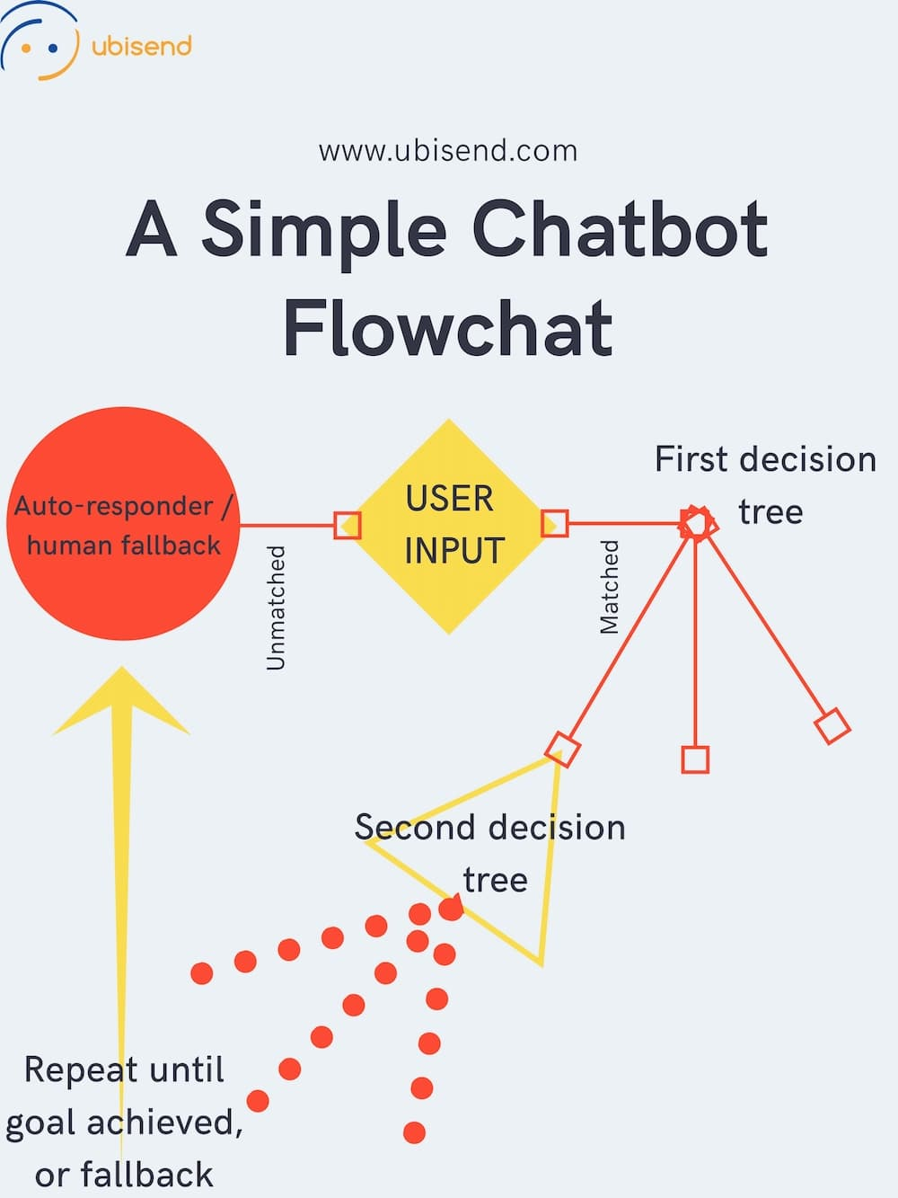

Fig: 3.3.1. **Simple flowchart**

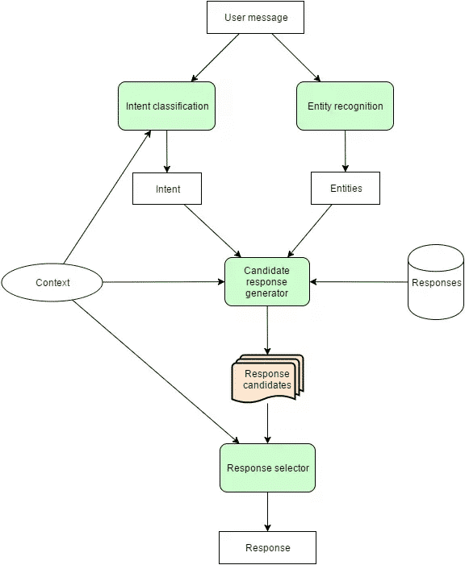

Fig:3.3.2. **basic flowchart**

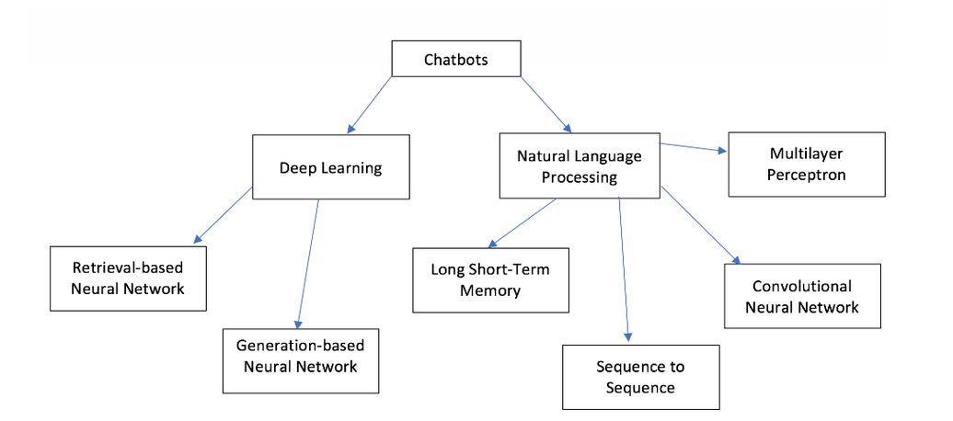

Fig: 3.3.3. **Student flowchart**

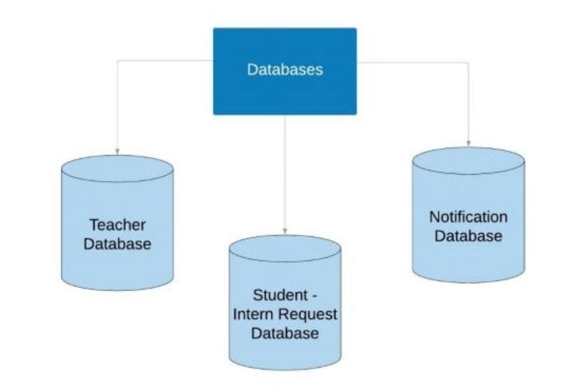

Fig: 3.3.4. Database flowchart

**3.4. Reports of Smart Bot website System**

* It generates the report on physically challenged Students Sessions
* Provide filter reports on smart answering website
* You can easily export PDF
* Vast study materials available at one place
* Specially working for helping blind people

**3.4.1. Modules of Smart Bot System**

* Home page Module: Used for managing all details
* Lectures Module: Used for managing the details of Lectures
* Managing Sessions Module: Used for managing the details of Managing Sessions
* Students Management Module: Used for managing the information and details of the Students
* Employees Module: Used for managing the Employees details
* Courses Module: Used for managing the Courses information
* Login Module: Used for managing the login details
* Users Module: Used for managing the users of the system.

**3.5. Features of the project:**

* Product and Component based
* Creating & Changing Issues at ease
* Query Issue List to any depth
* Reporting & Charting in more comprehensive way
* User Accounts to control the access and maintain security
* Simple Status & Resolutions
* Multi-level Priorities & Severities.
* Targets & Milestones for guiding the programmers
* Attachments & Additional Comments for more information
* Robust database back-end
* Various level of reports available with a lot of filter criteria's
* It contains better storage capacity.
* Accuracy in work
* Easy & fast retrieval of information.
* Well-designed reports.
* Decrease the load of the person involve in existing manual system
* Access of any information individually.
* Work becomes very speedy
* Easy to update information

**3.6. Input Data and Validation**

* All the fields such as students, Employees, Lectures are validated and does not take invalid values
* Each form for Students, Materials Sessions cannot accept blank value fields
* Avoiding errors in data
* Controlling amount of input
* Integration of all the modules/forms in the system.
* Preparation of the test cases
* Preparation of the possible test data with all the validation checks.
* Actual testing done manually.
* Recording of all the reproduced errors
* Modifications done for the errors found during testing
* Prepared the test result scripts after rectification of the errors.
* Functionality of the entire module/forms
* Validations for user input.
* Checking of the Coding standards to be maintained during coding. Testing the module with all the possible test data.
* Testing of the functionality involving all type of calculations etc.
* Commenting standard in the source files.

**3.6.1. The software quality plan we will use the following SQA Strategy**

* In the first step, we will select the test factors and rank them. The selected test factors such as reliability, maintainability, portability or etc, will be placed in the

matrix according to their ranks.

* The second step is for identifying the phases of the development process. The phase should be recorded in the matrix.
* The third step is that identifying the business risks of the software deliverables. The risks will be ranked into three ranks such as high, medium and low.

1. **OBJECTIVE OF THE STUDY**

**4.1. Objective**

The main objective of the Smart Bot website System is we are designing a smart answering “BOT” (SMART BOT) which will reply to the queries instantly. This smart BOT will be facilitated with special audio feature to help “DIVYANG” peoples (particularly BLIND). We are building a smart BOT that can help learner who have the issues related to English grammar. This bot is designed for “DIVYANG” people (especially blind) as it has smart reply system. The BOT will reply the queries instantly.

**4.1.1. Functionalities provided by Smart Bot website System are as follows:**

* Provides the searching facilities based on various factors.
* Smart interaction mode
* It tracks all the information of requirement of user
* Manage the information of Students
* Smart learning means that a Smart Bot has ability to learn from each user interaction
* It deals with monitoring the information and transactions of Courses.
* Remembering the pattern of queries and replies
* Able to recognize future users need for additional information

**4.2. Software Requirement Specification**

The Software Requirements Specification is produced at the culmination of the analysis task. The function and performance allocated to software as part of system engineering are refined by establishing a complete information description, a detailed functional and behavioral description, an indication of performance requirements and design constraints, appropriate validation criteria, and other data pertinent to requirements.

**4.2.1. The proposed system has the following requirements:**

* System needs store information
* System needs to help the Students and provide them required materials
* System need to maintain quantity record.
* System need to keep the record of grammar content
* System need to update content when modified
* System also needs a search area. It also needs a security system to prevent data.

**4.3. Identification of need**

The old manual system was suffering from a series of drawbacks. This study investigated the technical difficulties and technical assistance that blind adults experienced when interacting with computers and computing applications. Smart Bot studying can be an effective aid for students. Although not all students are kids, the process of interaction needs to be engaging. This process needs to be scientific, and at the same time, effective. When kids have access to technology, distractions are likely to occur.

However, the learning process has to be designed in such a way, that the study materials get assimilated lucidly. When education becomes interesting, students will be willing to learn. Exposure to technology, when properly guided, can enhance the knowledge-acquisition process.

At times, lessons become boring on paper. The Smart Bot are integrated with features like video conferencing, live document and video sharing, texting and much more. All these elements make the learning process engaging.

Therefore, they enjoy a greater degree of interaction as compared to learning on paper. Reputed online institutes across the world have successfully implemented the process. Experiments are being carried out to enhance the teaching abilities of Smart Bot.

**4.3.1. Following points should be well considered:**

* Documents and reports that must be provided by the new system there can also be few reports, which can help management in decision-making and cost controlling, but since these reports do not get required attention, such kind of reports and information were also identified and given required attention.
* Details of the information needed for each document and report.
* The required frequency and distribution for each document.
* Probable sources of information for each document and report.
* With the implementation of computerized system, the task of keeping records in an organized manner will be solved. The greatest of all is the retrieval of information, which will be at the click of the mouse. So the proposed system helps in saving the time in different operations and making information flow easy giving valuable reports.

**4.4. Feasibility Study**

After doing the project Smart Bot system study and analyzing all the existing or required functionalities of the system, the next task is to do the feasibility study for the project. All projects are feasible given unlimited resources and infinite time. Feasibility study includes consideration of all the possible ways to provide a solution to the given problem. The proposed solution should satisfy all the user requirements and should be flexible enough so that future changes can be easily done based on the future upcoming requirements.

1. **Economic Feasibility**

This is a very important aspect to be considered while developing a project. We decided the technology based on minimum possible cost factor.

* All hardware and software cost has to be borne by the organization.
* Overall, we have estimated that the benefits the organization is going to receive from the proposed system will surely overcome the initial costs and the later on running cost for system.

1. **Technical Feasibility**

This included the study of function, performance and constraints that may affect the ability to achieve an acceptable system. For this feasibility study, we studied complete functionality to be provided in the system, as described in the System Requirement Specification (SRS), and checked if everything was possible using different type of frontend and backend platforms

1. **Operational Feasibility**

No doubt the proposed system is fully GUI based that is very user friendly and all inputs to be taken all self-explanatory even to a layman. Besides, a proper training has been conducted to let know the essence of the system to the users so that they feel comfortable with new system.

1. **RESEARCH METHODOLOGY**

**(SYSTEM FLOWCHART AND DIAGRAM)**

**5.1. System Design of Smart Bot website System**

In this phase, a logical system is built which fulfils the given requirements. Design phase of software development deals with transforming the client’s requirements into a logically working system. Normally, design is performed in the following in the following two steps:

**1. Primary Design Phase:**

In this phase, the system is designed at block level. The blocks are created on the basis of analysis done in the problem identification phase. Different blocks are created for different functions emphasis is put on minimizing the information flow between blocks. Thus, all activities which require more interaction are kept in one block.

**2. Secondary Design Phase**:

In the secondary phase the detailed design of every block is performed.

**5.1.1. The general tasks involved in the design process are the following:**

* 1. Design various blocks for overall system processes.
  2. Design smaller, compact and workable modules in each block.
  3. Design various database structures.
  4. Specify details of programs to achieve desired functionality.
  5. Design the form of inputs, and outputs of the system.
  6. Perform documentation of the design.
  7. System reviews.

**5.2. User Interface Design**

User Interface Design is concerned with the dialogue between a user and the computer. It is concerned with everything from starting the system or logging into the system to the eventually presentation of desired inputs and outputs. The overall flow of screens and messages is called a dialogue.

**5.2.1. The following steps are various guidelines for User Interface Design:**

1. The system user should always be aware of what to do next.
2. The screen should be formatted so that various types of information, instructions and messages always appear in the same general display area.
3. Message, instructions or information should be displayed long enough to allow the system user to read them.
4. Use display attributes sparingly.
5. Default values for fields and answers to be entered by the user should be specified.
6. A user should not be allowed to proceed without correcting an error
7. The system user should never get an operating system message or fatal error

**5.3. Preliminary Product Description**

The first step in the system development life cycle is the preliminary investigation to determine the feasibility of the system. The purpose of the preliminary investigation is to evaluate project requests. It is not a design study nor does it include the collection of details to describe the business system in all respect Rather, it is the collecting of information that helps committee members to evaluate the merits of the project request and make an informed judgment about the feasibility of the proposed project.

**5.3.1. Analysts working on the preliminary investigation should accomplish the following objectives:**

* Clarify and understand the project request
* Determine the size of the project.
* Assess costs and benefits of alternative approaches • Determine the technical and operational feasibility of alternative approaches.
* Report the findings to management, with recommendations outlining the acceptance or rejection of the proposal.
* Benefit to Organization.

The organization will obviously be able to gain benefits such as savings in operating cost, reduction in paperwork, better utilization human resources and more presentable image increasing goodwill

* The Initial Cost

The initial cost of setting up the system will include the cost of hardware software (OS, add-on software, utilities) labour (setup & maintenance). The same has to bear by the organization.

* Running Cost

Besides, the initial cost the long-term cost will include the running cost for the system including the AMC, stationary charges, cost for human resources, cost for update/renewal of various related software.

* Need for Training

The users along with the administrator need to be trained at the time of implementation of the system for smooth running of the system. The client will provide the training site.

In recent years, the growth of the eLearning industry has been phenomenal. From web development and marketing to woodwork and knitting, training of any kind can be imparted online. Through online training, people across the world can receive education.

However, web-based learning involves no real classes, as the process takes place virtually. The lack of personalization turns out to be a constraint at times. However, Smart Bot are able to mitigate this problem to a significant extent. A study reveals that just 7% of people enrolling for courses online actually complete them.

The primary reason for this dismal figure is the lack of feedback and support that the students experience. Traditionally, online classes have been pre-recorded, which are circulated through online channels.

Smart Bot can resolve this crisis, making the learning process more effective. These bots assume the role of tutors or teachers, making the learning process interactive and engaging.

**5.4. Project Category**

AI and machine learning have enabled bots to contextualize the information during an ongoing conversation. They can reply in an engaging, personal and conversational way. The learners get individual care, which is necessary during the learning process. We are also using HTML and CSS for designing website.

**5.4.1. Brief Introduction about AI**

Artificial Intelligence (AI) is a field that has a long history but is still constantly and actively growing and changing. In this course, you’ll learn the basics of modern AI as well as some of the representative applications of AI. Along the way, we also hope to excite you about the numerous applications and huge possibilities in the field of AI, which continues to expand human capability beyond our imagination.

Artificial intelligence (AI) is intelligence demonstrated by machines, unlike the natural intelligence displayed by humans and animals, which involves consciousness and emotionality. The distinction between the former and the latter categories is often revealed by the acronym chosen. 'Strong' AI is usually labelled as artificial general intelligence (AGI) while attempts to emulate 'natural' intelligence have been called artificial biological intelligence (ABI).

Leading AI textbooks define the field as the study of "intelligent agents": any device that perceives its environment and takes actions that maximize its chance of successfully achieving its goals. Colloquially, the term "artificial intelligence" is often used to describe machines that mimic "cognitive" functions that humans associate with the human mind, such as "learning" and "problem solving".

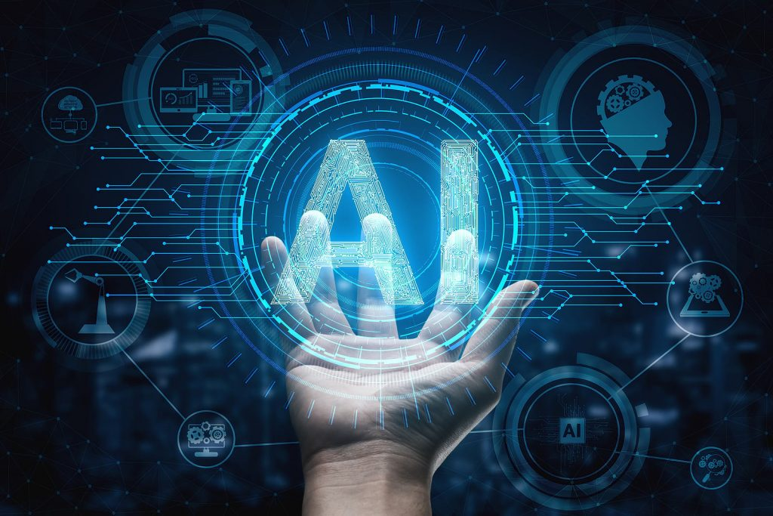

**5.5. Implementation Methodology**

HTML (Hypertext Markup Language) is the primary building block of creating a website. HTML is a very basic markup language and requires memorization of a few dozen HTML commands that structure the look and layout of a web page. Before writing any HTML code or designing your first web page, you must decide on an HTML editor or text editor, such as Notepad or WordPad.

After installing an HTML editor and are ready to begin setting up your website, think about how you want the site to look and be set up. Consider even drawing out your ideas, to help visualize the site and pages on the site. Below are some considerations to think about when designing your web page.

CSS is the language for describing the presentation of Web pages, including colors, layout, and fonts. It allows one to adapt the presentation to different types of devices, such as large screens, small screens, or printers. CSS is independent of HTML and can be used with any XML-based markup language.

**5.6. System Analysis:**

System analysis is a process of gathering and interpreting facts, diagnosing problems and the information about the Smart Bot website system to recommend improvements on the system. It is a problem-solving activity that requires intensive communication between the system users and system developers.

System analysis or study is an important phase of any system development process. The system is studied to the minutest detail and analyzed. The system analyst plays the role of the interrogator and dwells deep into the working of the present system.

The system is viewed as a whole and the input to the system are identified. The outputs from the organizations are traced to the various processes System analysis concerned with becoming aware of the problem, identifying the relevant and decisional variables.

Analyzing and synthesizing the various factors and determining an optimal or at least a satisfactory solution or program of action. A detailed study of the process must be made by various techniques like interviews, questionnaires etc. The data collected by these sources must be scrutinized to arrive to a conclusion. The conclusion is an understanding of how the system functions. This system is called the existing system. Now the existing system subjected to close study and problem areas are identified. The designer now functions as a problem solver and tries to sort out the difficulties that the enterprise faces.

The solutions are given as proposals. The proposal is then weighed with the existing system analytically and the best one is selected. The proposal is presented to the user for an endorsement by the user. The proposal is reviewed on user request and suitable changes are made.

This is loop that ends as soon as the user is satisfied with proposal.

Preliminary study is the process of gathering and interpreting facts, using the information for further studies on the system. Preliminary study is problem solving activity that requires intensive communication between the system users and system developers. It does various feasibility studies. In these studies, a rough figure of the system activities can be obtained, from which the decision about the strategies to be followed for effective system study and analysis can be taken.

**5.7. Existing System of Smart Bot website System:**

In the existing system the exams are done only manually but in proposed system have to computerize the using this application.

* Lack of security of data.
* More man power.
* Time consuming
* Consumes large volume of pare work
* Needs manual calculations.
* No direct role higher officials

**5.8. Proposed System of Smart Bot website System**

The aim of proposed system is to develop a system of improved facilities. The proposed system can overcome all the limitations of the existing system. The system provides proper security and reduces the manual work.

* Security of data.
* Ensure data accuracies.
* Proper control of the higher officials.
* Minimum time needed for the various processing
* Greater efficiency
* Better service.
* User friendliness and interactive.
* Minimum time required.

1. **COMPLETE WORK PLAN WITH TIMELINES**

**6.1. Project Planning:**

Software project plan can be viewed as the following:

**1) Within the organization:** How the project is to be implemented? What are

Various constraints (time, cost, staff)? What is market strategy?

**2) With respect to the customer** Weekly or timely meetings with the customer with presentation on status reports. Customer’s feedback is also taken and further modification and developments are done. Project milestones and deliverables are also presented to the customer.

**6.1.1. For a successful software project, the following steps can be followed**

* Select a project
* Identifying project's aims and objectives
* Understanding requirements and specification
* Methods of analysis, design and implementation
* Testing techniques
* a Documentation
* Project milestones and deliverables
* Budget allocation
* Exceeding limits within control
* Project Estimates
* Cost
* Time
* Size of code
* Duration
* Resource Allocation
* Hardware
* Software
* Previous relevant project information
* Digital Library
* Risk Management
* Risk avoidance
* a Risk detection

**6.2. Cost estimation of the project:**

Software cost comprises a small percentage of overall computer-based system cost there are a number of factors which are considered, that can affect the ultimate cost of the software such as-human, technical, Hardware and Software availability etc.

The main point that was considered during the cost estimation of project was its sizing

In spite of complete software sizing, function point and approximate lines of code were

Also used to "size" each element of the Software and their costing

The cost estimation done by me for Project also depend upon the baseline metrics collected from past projects and these were used in conjunction with estimation variables to develop cost and effort projections.

We have basically estimated this project mainly on two bases

**1) Effort Estimation** -This refers to the total man-hours required for the development of the project. It even includes the time required for doing documentation and user manual.

**2) Hardware Required Estimation** -This includes the cost of the PCs and the hardware cost required for development of this project.

**6.3. Hardware and Software Requirement specifications:**

**6.3.1. Software Requirements**

**Table: 6.1**

|  |  |
| --- | --- |
| **Name of component** | **Specification** |
| Operating System | Windows XP, Windows10 |
| Language | HTML , CSS |
| Database | MySQL Server |
| Browser | Any of Mozilla, Opera, Chrome etc |
| Web Server | Tomcat 7 |

**6.3.2. Hardware Requirements**

**Table:6.2**

|  |  |
| --- | --- |
| **Name of component** | **Specification** |
| Processor | Pentium III 630MHz |
| RAM | 128 MB |
| Hard disk | 20 GB |
| Monitor | 15 color monitors |
| Keyboard | 122 keys |

**6.4. Project Profile**

Smart Bot is widely popular now-a-days and catching speed as an application of computer communication. Some programs respond intelligently like human. This type of program is called a Smart Bot. This paper addresses the design and implementation of a Smart Bot system. We will also study another application where Smart Bots could be useful and techniques

Used while designing Smart Bot.

DESIGN OF SMART BOT

A Smart bot refers to a chatting robot. It is a communication simulating computer program. It is all about the conversation with the user. The conversation with a Smartbot is very simple. It answers to the questions asked by the user. During designing a Smartbot, how does the Smartbot speak to the user? And how will be the conversation with the user and the Smartbot is very important. The design of a Smartbot is represented using diagram as follows:

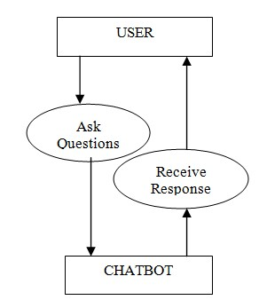

Fig.1: Use Case Diagram of smartbot Design.

The following facts are kept in mind during designing a Smartbot:

## **A. Selection of OS**

Windows is used for this project because it is user friendly. It is also robust.

## **B. Selection of Software**

Eclipse software is used for programming in java. Because it contains basic workspace and it is mostly used for java applications.

## **C. Creating a Smart bot**

For creating a Smart bot, a program has to be written. Java programming language is used for programming. The smart bot is created in such a way to help the user, improve the communication and amuse the user.

## **D. Creating a Chat**

The chat is created using a pattern that is known to the user and could be easy to understand. Chat dialog box show up to create conversation. This dialog box is created using java applets.

## **E. Pattern Matching**

It is a technique of artificial intelligence used in the design of a Smartbot. The input is matched with the inputs saved in the database and corresponding response is returned.

## **F. Simple**

The design of a Smart bot is very simple. It just answers to the questions asked by the user, if the question is found in the database.

## **G. Conversational and Entertaining**

The Smart bot responses are a way known to the user. The conversation follows a Basic English language and interacts in an easy to read manner. The conversation between the user and the Bot is entertaining. It is like talking to other person.

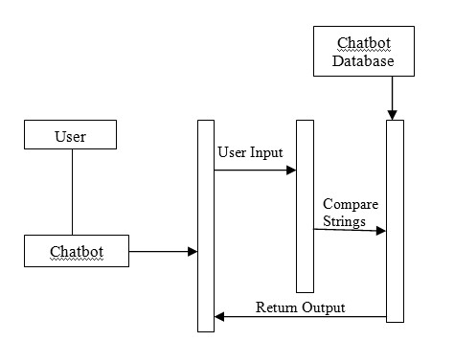

Fig. 2: Sequence Diagram Representing Design of the Smartbot.

**III. IMPLEMENTATION PROCESS** Smart bot is a computer application which uses artificial intelligence to mimic human conversation. It helps the user by answering the questions asked by them. The program is implemented using Java programming language. Particularly Java applets are used. Applets are used because it is easy to create the dialog box required for the conversation between the user and the detailed implementation is given below

## **A. Fundamental Design Techniques and Approach Creating the dialog box**

*A*ll the packages required for creating the dialog box are imported. The size of the dialog box and text area inside the dialog box is given. Vertical scrollbar is used so that the screen is scrolled as the conversation goes on. Horizontal scrollbar is never used because the size of the dialog box is fixed.

## **Creating a database**

Two dimensional string arrays are applied to build a database. Rows in the array are used for request and response. All the even rows contain the request or questions and all the odd rows contain the response or answers. Columns in the array are applied to save different types of questions that could asked by the user and responses that a Smart bot can answer. There is one row in the array which contains default responses which is used when the matching question is not found in the array.

## **B. Modules Description**

The description of the modules used in the implementation is given below:

## **Smart bot**

In this function, all the variables used for creating the dialog box are added. Default close operation is set to EXIT_ON_CLOSE so that the dialog box closes on exit. Required background color is set using inbuilt set Background () function.

## **Random**

The input from the user is taken using get Text () function. All the punctuation marks in the users input are removed using trim () function. The uppercase letters are converted to lowercase. A variable called response is used to hold a byte value and it is set to 0. While response is 0, the match for the input is found in the database and it is returned as a response which is displayed in the text area. If the response is 1, then the match for the input is not found in the database. In this case, a default response is returned. Random () function is used to choose the response saved in the database.

**COMPARISION**

This Smartbot is very simple and user friendly. It is not very complicated like other Smartbot. The working of the Smartbot is simple and can be easily understood by any person. In other Smartbot, the working is very complicated. Many classes are used which is difficult to understand. In this program, only one class is used to make it simple and obtain the expected output.

This Smartbot uses simple pattern matching to represent the input and output whereas other Smartbot uses input rules, keyword patterns and output rules to generate a response. If the input is not found in the database, a default response is generated. The input and output can be customized according to the user. Based on the developer or the user, the required requests and responses can be stored in the database.

Since own database can be created, it allows the user to understand how the response is generated. This Smartbot can be used for the entertainment purpose. Whenever a person is bored, he can chat with the bot for entertainment. It can also be used to provide information by modifying the program as needed by the user.

**PURPOSED SYSTEM:**

* Smart Bot will be used to continue the flow of thinking of a person conversing so as to make the flow of thoughts easier and it can also be used by understand the mood or the topic which is being hinted at directly or indirectly rather than at just that instant in digital assistants. The product is supposed to help people chat at any mo3ment or have their mental health analysed when they want and accordingly understand more about what it is causing and what is causing it.
* User interfaces the user interface includes messenger or telegram API which acts with the software with the help of a webhook. • Software interfaces the system currently runs on messenger or telegram or on any system with python. • Communications interfaces Communication between Telegrams or Messenger occurs with the help of API which can be used through any system using ngrok. • Operations A Tensor Flow library seq2seq is used. It helps in identifying the content that can subsequently be used to train the Smartbot.The bot will as well be able to chat normally if any want wants to chat on any topic so that they can continue their thought process in a manner and apart from that the bot can be interacted so that a person can explore their mental condition and if possible as well find the cause for it and be able to understand more about their own standpoint on it. The chat-bot will be used to continue the flow of thinking of a person conversing so as to make the flow of thoughts easier and it can also be used by other machines to understand the mood or the topic which is being hinted at directly rather than just at the instant in digital assistants. The Smartbot will be able to engage the user in a conversation of their choice. It will be able to make the user aware of its emotions by changing the expression of the bot while conversing. The expressions given in response to the user’s query will be realistic and worldly.

USER CHARACTERISTICS

* People checking the level of understanding of the program- Turing Test These people will be checking the level of understanding of the chat-bot and see how well it can understand and interact like humans. People seeing extended possibilities of their thoughts People talking about random things because they wish to see what all can be expected from there thought process when standard questions are asked about it and see how their thought process goes with it. Digital Assistants they assist in our daily live activities and if they understand what the person want’s better they shall become better at what they do. People learning the language the program will consider that these people are not fluent in the language and understand them appropriately.

**Assumption & Dependencies**

Chat-bots are computer programs that interact with users using natural languages. They use natural language processes for interaction.  Chat-bot is a computer program which conducts a conversation. Chat-bots are also used in dialog systems for various practical purposes including customer service or information acquisition. Some chat-bots use sophisticated natural language processing systems, but many simply scan for keywords within the input and pull a reply with the most matching keywords, or the most similar wording pattern, from a textual database. The chat-bot being made will be able to understand the mood and respond in respect to that and understand the whole conversation. The person is fluent to a certain extent in the language and doesn’t jump from thoughts, goes in a flow and talks about one thing at a time and doesn’t continue talking about multiple thoughts at the same time. The user will try having a meaningful conversation and not be lashing out or talking about random things. Only one person will be conversing at one point of time.

Fluency of the person interacting will be a major limiting constraint as the software will take time to predict the fluency of the person and interact in that manner. Every person’s vocabulary is different and thus, there may be some phrases which people use which won’t be common and thus, the software won’t know about these phrases, and as well for certain words. When speaking referentially we are very vague and thus, the software may not be able to understand the topic. Subjectivity defines the sense in which people talk and can change the whole meaning of the conversation and if it is lingo or any one which the software hasn’t been programmed for the software will react in an unpredictable fashion. Self-Learning will be used in the manner of modelling so when the software has been interacting with a specific type of person a lot it will converse better with that person and when any other person uses the software who represents the phrases used in a different manner the software will react in the manner it would react to the first person and thus, will not respond correctly. Later modules will have login feature where a person can interact and a specific area of the database will be used to store the logs of that specific person thus, they do not affect any other person using the software.

* Domain Requirements
* Smartbot being used for self-learning and to understand different scenarios. The Smartbot should be able to remember the context of an ongoing conversation. It should be able to remember the interests of a user from their past conversations. An ongoing conversation should be domain specific, i.e. the Smartbot should not deviate from the topic. The Smartbot should have the ability to have a meaningful conversation with the user.
* User Requirements
* For the user to continue the conversation and give enough information to the bot and be true about the information and not mislead the bot. The software should remember the context of the conversation it has with the user.

  Non Functional Requirements

* Product Requirements
* Efficiency (in terms of Time and Space)
* Clustering depends on the features that are incorporated and inbuilt libraries are used for the implementation of each individual algorithm. The time complexity for training the neural network is O(n^2). For testing the time complexity is O(n*m) where n is the number or sentences and m determines the number of words in every sentence. Also, the time complexity when the user uses the system will also be O(n*m) with the same parameters as above.
* Reliability
* The bot will perform the same in the same condition but each condition is never the same and the bot will need to be trained to find the finer differences but have a limitation for overfitting and features.

   Portability

* The system is hosted on a server and can be used anywhere on a mobile or desktop as a web app.

   Usability

* Based on the requirements of the users and is going to be helpful in daily life to improve the living standards of people.
* Organizational Requirements
* Implementation Requirements (in terms of deployment)
* To receive an accurate output, a massive data set needs to be trained. Since, the objective is to create a chat bot, we need to train it in such a way that its vocabulary is up to the standard of the end user.  The quality of the data set will have a major impact on the acceptability of the system by the user. Apart from this, the system needs to be constantly tested and validated to avoid any failures. Due to the large amount of data, the overhead is a lot of testing and training this data. This slows the speed of implementation. Performing real-time animation also requires a lot of manual work. It is a constant trial-and-error affair, which eventually leads to an accurate result. Server to host and Telegram API as it is hosted on Telegram
* Engineering Standard Requirements
* The system will be able to converse with the user in English via text. It will be able to respond to any query instantly and appropriately. Copies of previous versions need to be kept so that if the bot gets over trained or self-learning is not in the right factor it can be reverted and done again. Changes in the algorithm happened at which instance and what difference would it create if the bot was trained from the starting will need to be considered.
* Operational Requirements (Explain the applicability for your work w.r.to the following operational requirement(s))
* Economic
* The Smartbot can help anyone check their mental health at any point of time and thus is useful for everyone.
* Environmental
* The basic use of the environment in the project is that at different situations the person is in a different mindset and it affects his mental health in different manners.
* Social
* The Smartbot will be socially aware. It is capable of detecting emotions while conversing with the user, reasoning about how to respond to the intentions behind those particular emotions, and generating appropriate social responses. The Smartbot will be trained well enough to be socially responsible. It will never suggest any reckless activity or behaviour to the user. The product can be used in various social situations. It is helpful in letting the person stay in a good mental condition and explore more about it at any given moment or condition.
* Ethical
* The Smartbot will ensure that private and sensitive information related to any conversation they have had with an individual remains safe since it’s important to maintain the security of the bot’s input and output databases in order to avoid the loss of sensitive information. The Smartbot would be ethical at all times and will not instigate the user to involve themselves in any activity that would be against the law.
* Sustainability
* The product can be sustained if all the system capability requirements are met with.
* Legality
* The Smartbot doesn’t persuade or suggest to the user to do anything illegal. The Smartbot will be accountable for all its actions and suggestions.
* Inspectability
* The system stores the data in encrypted form and moreover a person can have the option of having and loading their own data themselves so the data won’t be there anywhere else.

  System Requirements

  H/W Requirements (details about Application Specific Hardware)

* The proposed system is a software system  and can be used on any mobile or pc but requires a computer powerful enough to for training itself. The computer should preferably have a RAM of 8GB or more and an NVIDIA GPU that is capable of running the CUDA commands is preferred.
* S/W Requirements(details about Application Specific Software)
* The chat bot is developed in the python programming language, using the Tensorflow library for machine learning and deep learning. The entire list of libraries used and their dependencies are:
* Numpy
* Pandas
* Tensorflow
* Matplotlib
* Sqlite3
* Aiml
* Nltk
* Virtualenv
* The other software’s that are required are:
* Telegram or Messenger Webhook
* NGROK
* CUDA

**6.6. PERT CHART (Program Evaluation Review Technique)**

PERT chart is organized for events, activities or tasks. It is a scheduling device that i shows graphically the order the tasks to be performed. It enables the calculation of the critical path. The time and cost associated along a path is calculated and the path requires the greatest amount of elapsed time critical path.

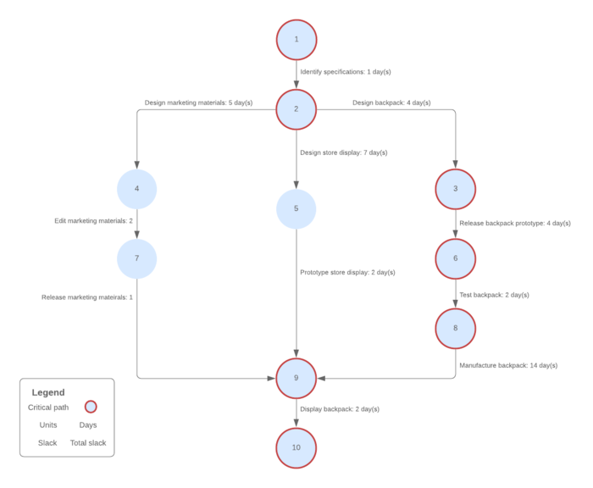

Fig:6.1. **Pert chart**

**6.7. GANTT CHART**

It is also known as Bar chart is used exclusively for scheduling purpose. It is a project controlling technique. It is used for scheduling Budgeting and resourcing planning. A Gantt is a bar chart with each bar representing activity. The bars are drawn against a time line. The length of time planned for the activity. The Gantt chart in the figure shows the Gray parts in slack time that is the latest by which a task has been finished.

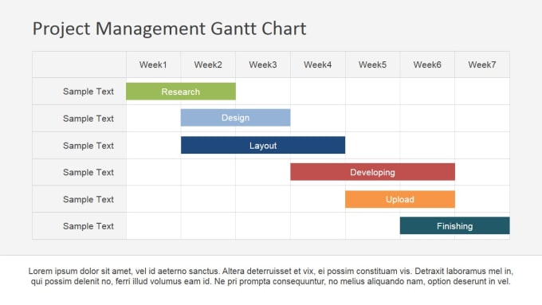

Fig: 6.2. **Gantt chart**

**6.8. Use Case Model of the Project:**

The use case model for any system consists of use cases Use cases represent different ways in which the system can be used by the user. A simple way to find all the use case of a system is to ask the questions "What the user can do using the system?" The use cases partition the system behavior into transactions such that each transaction performs some useful action from the users’ point of view.

The purpose of the use case to define a piece of coherent behavior without revealing the internal structure of the system. A use case typically represents a sequence of interaction between the user and the system. These interactions consist of one main line sequence is represent the normal interaction between the user and the system. The use case model an important analysis and design artifact (task) Use cases can be represented by drawing a use case diagram and writing an accompany text elaborating the drawing.

In the use case diagram, each use case represented by an ellipse with the name of use case written inside the ellipse. All the ellipses of the system are enclosed with in a rectangle which represents the system boundary. The name of the system being moduled appears inside the rectangle. The different users of the system are represented by using stick person icon. The stick person icon is normally referred to as an Actor. The line connecting the actor and the use cases is called the communication relationship. When a stick person icon represents an external system, it is annotated by the stereo type external system

**6.9. About ER Diagram:**

**6.9.1. Entity Relationship Diagram**

E-R Model is a popular high-level conceptual data model. This model and its variations are frequently used for the conceptual design of database application and many database design tools employ its concept.

A database that confirms to an E-R diagram can be represented by a collection of tables in the relational system. The mapping of E-R diagram to the entities are:

* Attributes
* Relations
* Many-to-many
* Many-to-one
* One-to-many
* One-to-one
* Weak entities
* Sub-type and super-type

The entities and their relationships between them are shown using the following

Conventions

* An entity is shown in rectangle.
* A diamond represents the relationship among number of entities.
* The attributes shown as ovals are connected to the entities or relationship by lines.
* Diamond, oval and relationships are labeled.
* Model is an abstraction process that hides super details while highlighting details relation to application at end.
* A data model is a mechanism that provides this abstraction for database application
* Data modeling is used for representing entities and their relationship in the database
* Entities are the basic units used in modeling database entities can have concrete existence or constitute ideas or concepts.
* Entity type or entity set is a group of similar objects concern to an organization for which it maintains data.
* Properties are characteristics of an entity also called as attributes. A key is a single attribute or combination of 2 or more attributes of an entity set is used to identify one or more instances of the set.
* In relational model we represent the entity by a relation and use tuples to represent an instance of the entity.
* Relationship is used in data modeling to represent in association between an entity set.
* An association between two attributes indicates that the values of the associated attributes are independent.

**6.11. Implementation and Software Specification Testing**

**6.11.1. Detailed Design of Implementation**

This phase of the systems development life cycle refines hardware and software specifications establishes programming plans, trains users and implements extensive testing procedures, to evaluate design and operating specifications and/or provide the basis for further modification.

**Technical Design**

This activity builds upon specifications produced during new system design, adding detailed technical specifications and documentation

**Test Specifications and Planning**

This activity prepares detailed test specifications for individual modules and programs, job streams, subsystems, and for the system as a whole.

**Programming and Testing**

This activity encompasses actual development, writing, and testing of program units or modules.

**User Training**

This activity encompasses writing user procedure manuals, preparation of user training materials, conducting training programs, and testing procedures.

**Acceptance Test**

A final procedural review to demonstrate a system and secure user approval before a system becomes operational

**Installation Phase**

In this phase the new computerized system is installed, the conversion to new procedures is fully implemented, and the potential of the new system is explored

**System Installation**

The process of starting the actual use of a system and training user personnel in its operation

**Review Phase**

This phase evaluates the successes and failures during a systems development project, and to measure the results of a new Computerized Transystem in terms of benefits and savings projected at the start of the project.

**Development Recap**

A review of project immediately after completion to find successes and in potential problem in

Future work

**Post-Implementation Review**

A review, conducted after a new system has been in operation for some time, to evaluate actual system performance against original expectations and projections for cost-benefit improvements. Also identifies maintenance projects to enhance or improve the system.

**6.11.2.** **The steps in the software testing:**

The steps involved during Unit testing are as follows:

1. Preparation of the test cases
2. Preparation of the possible test data with all the validation checks
3. Complete code review of the module
4. Actual testing done manually.
5. Modifications done for the errors found during testing.
6. Prepared the test result scripts.

**6.11.3. The unit testing done included the testing of the following items:**

1. Functionality of the entire module/forms
2. Validations for user input
3. Checking of the Coding standards to be maintained during coding
4. Testing the module with all the possible test data
5. Testing of the functionality involving all type of calculations et
6. Commenting standard in the source files.

After completing the Unit testing of all the modules, the whole system is integrated with all its dependencies in that module. While System Integration, We integrated the modules one by one and tested the system at each step. This helped in reduction of errors at the time of the system testing.

**6.11.4. The steps involved during System testing are as follows:**

* Integration of al modules/forms in the system
* Preparation of the test cases
* Preparation of the possible test data with all the validation checks
* Actual testing done manually,
* Recording of all the reproduced errors.
* Modifications done for the errors found during testing
* Prepared the test result scripts after rectification of the errors.

**6.11.5. The System Testing done included the testing of the following items:**

1. Functionality of the entire system as a whole.
2. 2 User Interface of the system
3. Testing the dependent modules together with all the possible test data scripts
4. Verification and Validation testing
5. Testing the reports with all its functionality.

After the completion of system testing, the next following phase was the Acceptance Testing Clients at their end did this and accepted the system with appreciation. Thus, we reached the final phase of the project delivery.

**6.11.6. There are other six tests, which fall under special category. They are described below:**

* Peak Load Test It determines whether the system will handle the volume of activities that occur when the system is at the peak of its processing demand. For example, test the system by activating all terminals at the same time.
* Storage Testing: It determines the capacity of the system to store transaction data on a disk or in other files.
* Performance Time Testing: it determines the length of time system used by the system to process transaction data. This test is conducted prior to implementation to determine how long it takes to get a response to an inquiry, make a backup copy of a fie, or send a transmission and get a response.
* Recovery Testing: This testing determines the ability of user to recover data or re-start system after failure. For example, load backup copy of data and resume processing without data or integrity loss
* Procedure Testing: it determines the clarity of documentation on operation and uses of system by having users do exactly what manuals request. For example, powering down system at the end of week or responding to paper-out light on printer.
* Human Factors Testing: It determines how users will use the system when processing data or preparing reports.

**6.12. Data Dictionary**

This is normally represented as the data about data. It is also termed as metadata some times which gives the data about the data stored in the database. It defines each data term encountered during the analysis and design of a new system. Data elements can describe files or the processes.

Following are some major symbols used in the data dictionary:

* = equivalent to
* + and
* [] either or
* () Optional entry

**6.12.1. Following are some rules, which defines the construction of data dictionary entries**:

1. Words should be defined to understand for what they need and not the variable need by which they may be described in the program
2. Each word must be unique. We cannot have two definition of the same client.
3. Aliases or synonyms are allowed when two or more enters shows the same meaning. For example, a vendor number may also be called as customer number
4. A self-defining word should not be decomposed. It means that the reduction of any information in to subpart should be done only if it is really required that is it is not easy to understand directly.

Data dictionary includes information such as the number of records in file, the frequency a process will run, security factor like pass word which user must enter to get excess to the information.

1. **RESULTS AND DISCUSSIONS**

**7.1. User Interfaces**

**7.1.1. HOME SECTION**

**7.1.2. TOPIC SECTION**

**7.1.3. ABOUT US SECTION**

**7.1.4. CONTACT SECTION**

**7.1.5. CONTENT SECTION**

**7.1.6 FEATURE SECTION**

**7.1.7 SMART BOT ICON**

**7.2. Future Scope of the Project:**

In a nutshell, it can be summarized that the future scope of the project circles around maintaining information regarding:

Smartbot are also referred to as virtual assistants. It is a rudimentary form of artificial intelligence software that can mimic human conversation.

The Smartbot can be analyzed and improved. It can be used in various fields such as education, business, online chatting etc. It can be used in the field of education as a learning tool. The information necessary for education can be stored in the data base and can be retrieved any time by querying the bot.

In business field, it can be used to provide business solutions in an efficient way. When the solutions are efficient, the business can be improved and the growth of the organization will be increased.

This Smartbot can be used in online chatting for entertainment purpose. People can chat with these bots online when they are bored for the purpose of entertainment. These bots can also be used to learn different kinds of language. The language that has to learnt can be stored in the database and can be learnt by asking questions to the bot. They can also be used in the field of medical to solve health related problems

.

Smartbot are going to explode and can be really dominating in future. Smartbot can provide a new and flexible way for users. They are giving AI something better to do. Smartbot results in smart conversation and is advancing at an unprecedented rate with each new development.

**7.3. Limitation of Project**

Although I have put my best efforts to make the software flexible, easy to operate but limitations cannot be ruled out even by me. Though the software presents a broad range of options to its users some intricate options could not be covered into it, partly because logistic and partly due to lack of sophistication. Paucity of time was also major constraint; thus, it was not possible to make the software foolproof and dynamic Lack of time also compelled me to ignore some part such as storing old result of the candidate etc.

**7.3.1. List of limitations which is available in the smart bot system:**

Limitations:

The bot can be lead astray or fooled easily by the user. The bot doesn’t easily change topics. Requires a lot of data before it can be trained again. The bot can’t answer questions if the user asks it to explain something. Future Work: The categories for classification can be improved using the following methods

.Random forest:

Random forests or random decision forests are an ensemble learning method for classification, regression and other tasks, that operate by constructing a multitude of decision trees at training time and outputting the class that is the mode of the classes (classification) or mean prediction (regression) of the individual trees.

1. **CONCLUSIONS**

Our project is only a humble venture to satisfy the needs to manage their project work several user-friendly coding have also adopted. This package shall prove to be a powerful package in satisfying all the requirements of the Students and specially physically challenged persons.

It also understands the interests of the end user and tries to keep the user interested in the ongoing conversation. The bot is able to direct the user in the right direction and isolate the problem to a certain extent

**At the end it is concluded that we have made effort on following points...**

* A description of the background and context of the project and to work already done in the area.
* Made statement of the aims and objectives of the project.
* The description of Purpose. Scope, and applicability
* We define the problem on which we are working in the project
* We describe the requirement Specifications of the system and the actions that can be done on these things.
* We understand the problem domain and produce a model of the system, which describes operations that can be performed on the system. We included features and operations in detail, including screen layouts.
* We designed user interface and security issues related to system.
* Finally, the system is implemented and tested according to test cases.

1. **REFRENCES AND BIBLIOGRAPHY**

* Google for problem solving
* http://www.javaworld.com/javaworld/jw-01-1998/jw-01-Credentialreview.html
* Database Programming with JDBC and Java by O'Reilly
* Head First Java 2nd Edition
* http://www.jdbc-tutorial.com/
* Java and Software Design Concepts by Apress
* https://www.tutorialspoint.com/java/
* http://www.javatpoint.com/java-tutorial
* https://docs.oracle.com/javase/tutorial/
* http://www.wampserver.com/en/
* http://www.JSP.net!
* http://www.tutorialspoint.com/mysql/
* httpd.apache.org/docs/2.0/misc/tutorials.html